SECTION 4
- Check the appropriate box in subsection C on the form, then delete the two subsections below which were not selected. You should be able to complete this yourself with just the subcontract, scope of supply, and vendor quote/proposal documents. If not, ask the Tech Rep to assist.
- Do not forget to include the HTSUS required by section 4D either on the form itself or as a “4D” line below.

Either
(1) Standard catalogue instrument.
- List the instrument and each accompanying accessory according to the foreign manufacturer's nomenclature and model number. (Attaching a bona fide order will suffice if the order fully and accurately describes the instrument and all accompanying accessories.)
- Attach the foreign manufacturer's literature that fully describes the instrument (with accompanying accessories) and its guaranteed specifications.

OR
(2) Special-order variant of standard catalogue instrument that has been significantly modified according to applicant's specifications.
- List the instrument and each accompanying accessory according to the foreign manufacturer's nomenclature and model number.
- Attach a copy of the applicant's specifications describing any required modifications of the standard catalogue instrument.
- Attach a copy of the foreign manufacturer's literature describing the instrument
- Indicate the extent to which each of the performance specifications applicable to the standard instrument has been increased or decreased in the modified instrument.

OR
(3) Instrument custom-made to applicant's specifications.
- List the instrument and each accompanying accessory according to standard nomenclature.
- Attach a copy of applicant's specifications.
- Attach documentation or evidence showing how the foreign instrument fulfills applicant's specifications described in (b) or, if it does not, attach evidence of the extent to which the article deviates from these specifications.

SECTION 7
Answer all questions below.

A. Description of research purposes.
- The identity of the materials or phenomena to be studied.
- The properties of the materials or phenomena to be investigated.
- The experiments to be conducted.
- The objectives pursued in the course of the investigations.
- The techniques used in employing the instrument to achieve the objectives.
- Other relevant information.

B. Description of science-related educational purposes.
(1) Name, content, and objectives of any course in which the instrument will be used.
(2) How the instrument will be used to achieve educational objectives
(3) Other relevant information.

C. Certification of intended use.
State the following:
"I hereby certify that there will not be any use of the foreign instrument by or for the primary benefit of any Commercial (for-profit) entity within 5 years after entry of the foreign instrument into the United States customs territory."

SECTION 8
Answer all questions in A, B, and C below.

- Are there instruments of the same general category as the foreign instrument being manufactured in the United States?

- Are there instruments not in the same general category as the foreign instrument being manufactured in the United States that could possibly be utilized for the purposes described in Question 7?

- Non-availability of a scientifically equivalent domestic instrument. (For further guidance on this item, see Sections 301.5(d)(1) and (2) of the regulations.)

- Identify any domestic instruments (cite manufacturers and model numbers) with which the foreign instrument has been compared.

- List and describe in detail the design, performance, and operational characteristics of the foreign instrument that you consider pertinent for your intended purposes and that are not equaled or exceeded by the comparable domestic instrument.

- Relate each characteristic listed in (2) to one or more purposes described in Question 7 by explaining how the availability of the characteristic permits you to accomplish the relevant purpose(s) that otherwise could not be achieved. Each characteristic must (1) be clearly described or discussed and (2) be quantitatively defined (wherever possible).

Delete the section below if you are checking the box for subsection 8D4 on the main form. If you are not checking that box, answer the questions below.
- If excessive delivery time of domestic instruments entered into the decision to order the foreign instrument, answer (1), (2) and (3), below. If not, check (4), below. (For further guidance on this question see Section 301.5(d)(4) of the regulations.)

- State and verify the delivery time quoted by each domestic manufacturer of an instrument comparable to the foreign instrument.

- State and verify the delivery time quoted by the foreign manufacturer.

- Explain why the delay in receiving the domestic instrument(s) would seriously impair the achievement of the intended purposes. Specify which purposes would be so impaired.

SECTION 9
Answer all questions below.

A: List names of domestic manufacturers contacted:

B: If you did not contact any domestic manufacturers prior to deciding to purchase the instrument, indicate the basis for concluding that no instruments manufactured in the United States were scientifically equivalent to the foreign instrument for the intended purposes.

C: Enclose copies of requests for bid, bid responses and any other relevant correspondence with the manufacturer of the foreign instrument and domestic manufacturers.

GENERAL SUBMISSION TIPS AND INFORMATION
- In Section 4D, if you have Adobe Acrobat and can edit PDFs, use the “Add Text” function to enter the HTS Code. If you are unable to edit PDFs, you can hand-write it in or else add a 4D line to the Section 4 Supplemental page above.
- Attach a post-it with the word “Original” to the copy with the wet ink signature.
- Use tabs for the individual sections (optional).
- Separate the five copies with clips (or some other way) because they get routed to different Federal departments.
- Include your email address with your name in Section 12, even though it is not requested.
- Prepare the first full package, and then make the four additional copies.
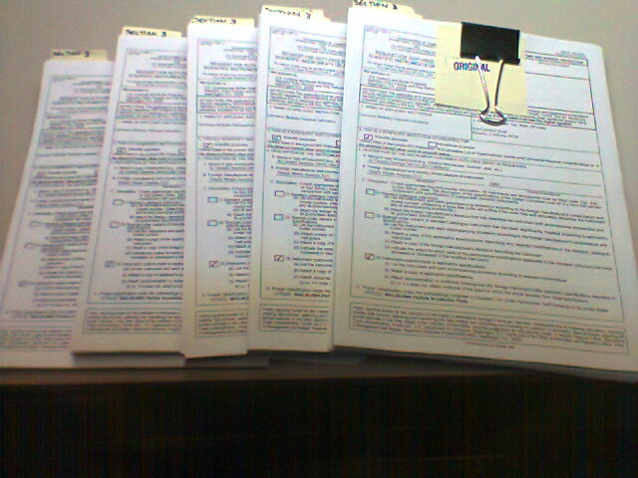

THE MAILING ADDRESS ON THE FORM MIGHT BE INCOMPLETE!
Some versions of the ITA-338P that can be downloaded from the internet have the submission address cut off. The full mailing address to be used for submitting your ITA-338P:

U.S. Customs and Border Protection
Attention: Entry Process and Duty Refunds Branch
90 K Street, NE, 10th Floor
Washington, D.C. 20229

- If your application is approved by CBP after their initial review, they will mail back one copy that has been stamped along with a letter that identifies your application’s docket number. Save these. CBP will forward three other copies to other Federal departments for the next phase.
- If your application is approved after the full process, you will receive a letter authorizing importation of the instrument under HTS 9810.00.60, which is duty (and tariff) free. You must provide a copy of this letter along with the copy of the ITA-338P that was stamped and returned to you by CBP to your customs broker if the delivery has not yet arrived.
- It takes 9 to 12 months for this application process, so unless your instrument has a very long lead-time, expect to pay the duties when the delivery reaches customs. Applications that are approved after delivery will receive a refund of duties paid.
- If delivery arrives before the application is approved and you pay duties, do not forget to submit the CBP Form 7501 Entry Summary as instructed in Section 10. However:

THE FAX AND PHONE NUMBERS IN SECTION 10 HAVE BEEN DISCONNECTED AS OF JULY 2025. YOU SHOULD SUBMIT THE 7501 TO CBP AT THE SAME ADDRESS, WITH A COVER LETTER LISTING THE ASSIGNED CASE NUMBER.

Full details of the Federal process are here:
https://www.trade.gov/florence-agreement-regulations

Some important highlights from the link above:
Burden of proof. The burden of proof shall be on the applicant to demonstrate that no instrument of equivalent scientific value for the purposes for which the foreign instrument is to be used is being manufactured in the United States. Evidence of applicant favoritism towards the foreign manufacturer (advantages not extended to domestic firms, such as additional lead time, know-how, methods, data on pertinent specifications or intended uses, results of research or development, tools, jigs, fixtures, parts, materials or test equipment) may be, at the Director’s discretion, grounds for rejecting the application.

Who may apply. An applicant for duty-free entry of an instrument under subheading 9810.00.60, HTSUS must be a public or private nonprofit institution which is established for educational or scientific purposes and which has placed a bona fide order or has a firm intention to place a bona fide order for a foreign instrument within 60 days following a favorable decision on the institution’s application.
Five copies of the form, including relevant supporting documents, must be submitted. One of these copies shall be signed in the original by the person in the applicant institution under whose direction and control the foreign instrument will be used and who is familiar with the intended uses of the instrument. The remaining four copies of the form may be copies of the original. Attachments should be fully identified and referenced to the question(s) on the form to which they relate.
A single application (in the requisite number of copies) may be submitted for any quantity of the same type or model of foreign instrument provided that the entire quantity is intended to be used for the same purposes and provided that all units are included on a single purchase order. A separate application shall be submitted for each different type or model or variation in the type or model of instrument for which duty-free entry is sought even if covered by a single purchase order. Orders calling for multiple deliveries of the same type or model of instrument over a substantial period of time may, at the discretion of the Director, require multiple applications.
Failure to answer completely all questions on the form in accordance with the instructions on the form or to supply the requisite number of copies of the form and supporting documents may result in delays in processing of the application while the deficiencies are remedied, return of the application without processing, or denial of the application without prejudice to resubmission.
Forwarding of applications to the Department of Commerce. If the Commissioner (CBP) finds the application to be within the scope of the Act and these regulations, CBP shall (1) assign a number to the application and (2) forward one copy to the Secretary of the Department of Health and Human Services (HHS), and two copies, including the one that has been signed in the original, to [Departments of Treasury and Commerce]. CBP shall retain one copy and return the remaining copy to the applicant stamped “Accepted for Transmittal to the Department of Commerce.” The applicant shall file the stamped copy of the form with the Port when formal entry of the article is made.

